Name :laraib salam
Sap id :61996
Lab :10
Tasks :1
Define a character array: 'H', 'e', 'l', 'l', 'o' and print each character.
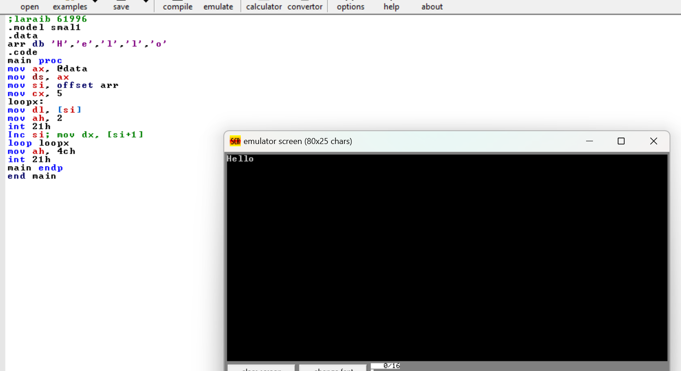

Tasks :2
Use DUP to create an array of 5 ‘#” characters and display them. 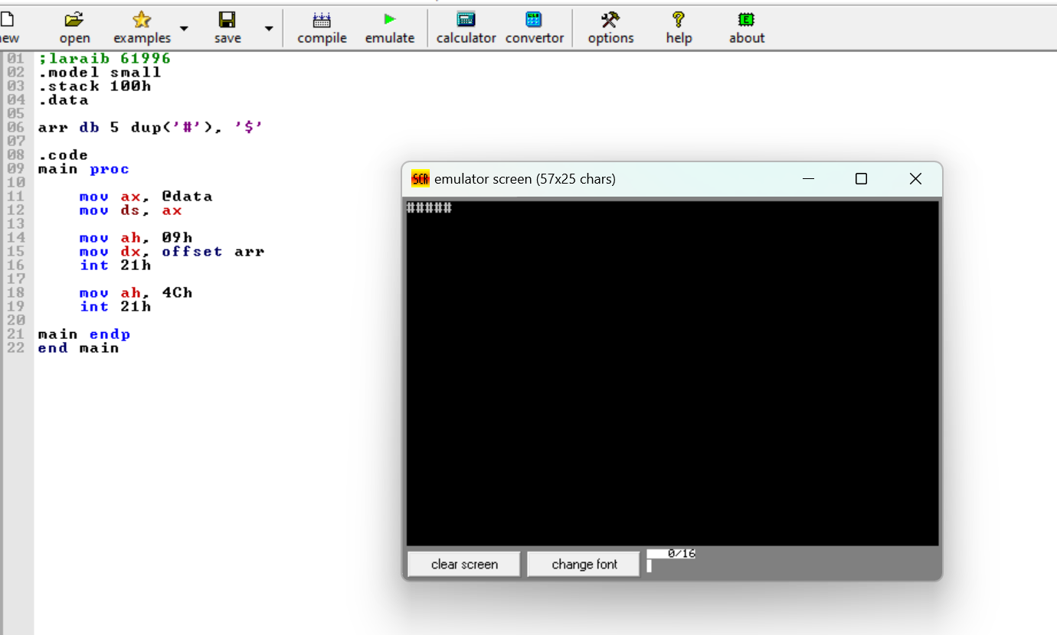
Tasks :3
Take 5 user inputs and store them in an array. Then display them.
